**🚖 NYC Taxi Dataset Analysis – Power BI Dashboard Project**



📌 Submitted by: [Rahul Chhabra](https://www.linkedin.com/in/rahul-chhabra-8804702a5/)  
📊 Tools Used: Power BI, NYC Taxi Dataset  
📁 Date Range: January 2015 sample  
🔍 Dataset Source: NYC Taxi & Limousine Commission (TLC)  
📦 Size: 50+ columns, millions of rows (sampled)

**🧭 Project Objective**

This project explores and analyzes the NYC Taxi dataset to identify patterns in:

* Taxi usage across time and geography
* Payment methods
* Fare and tip behavior

The ultimate goal is to uncover actionable insights that could support transportation policy, ride-sharing strategies, and customer experience enhancements.

**📚 Dataset Overview**

The NYC Taxi dataset from TLC includes extensive records on:

* Pickup/drop-off locations
* Distance traveled
* Fare details
* Payment methods
* Tipping behavior

The dataset provides a strong foundation for high-volume, real-time transportation analysis.

**❓ Key Questions Addressed**

**1**. **What is the most common trip distance?**

✅Insight:  
Most rides are under 3 miles, indicating frequent short-distance travel—common in busy metro areas.

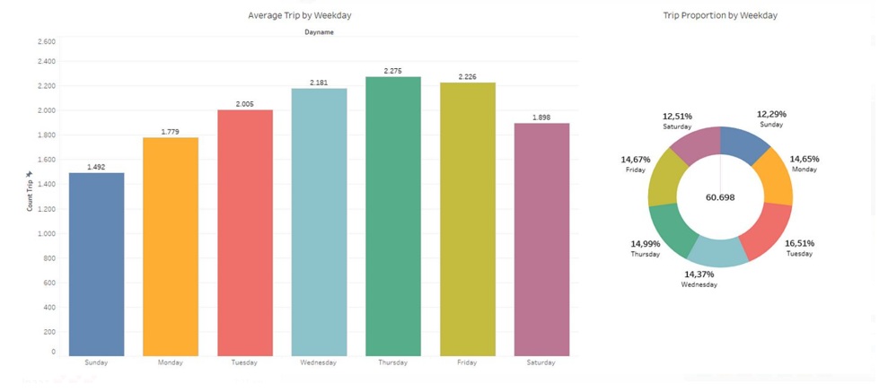

2. **What are the most preferred payment methods?**

✅ Insight:

* Apple Pay dominates (69.14%)
* Credit/Debit cards follow (30.55%)
* Cash is minimal (0.24%)

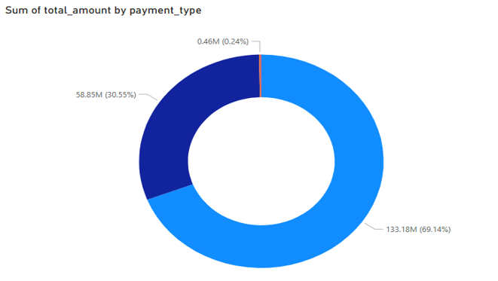

📌Implication:  
Cashless, app-based payments have become the norm, suggesting a strong digital payment infrastructure among riders.

3. **When do riders tip the most?**

✅Insight:  
Tips are highest during peak hours, likely due to:

* Longer trips
* Congestion-based gratitude
* Corporate travel behaviors

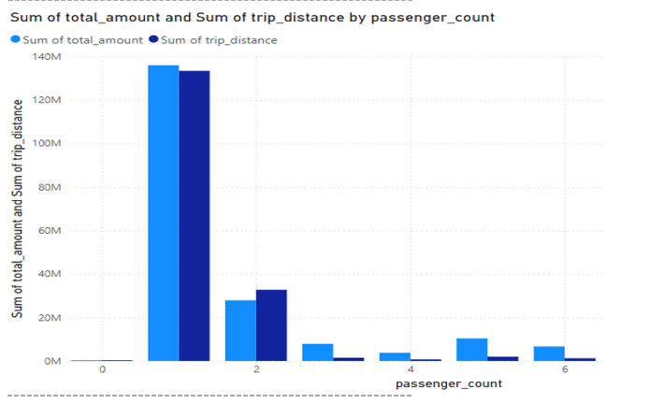

**📈 Dashboard Highlights**

Using Power BI, the following visuals were designed:

* Pie charts for payment distribution
* Bar charts for trip distance breakdown
* Time-based graphs to analyze tip percentages by hour

These visualizations enable stakeholders to grasp behavioral patterns in NYC’s taxi ecosystem quickly.

**📍 Key Takeaways**

* Short trips dominate urban travel.
* Contactless payment is a strong preference.
* Tip behavior aligns with daily commute trends.

**Business & Policy Implications**

* **Micro-mobility options** (like e-scooters or bike-sharing) can complement short-trip patterns.
* **App integration** with tipping options could be optimized during peak times.
* **Digital-first strategies** for payment and feedback can further enhance customer experience.